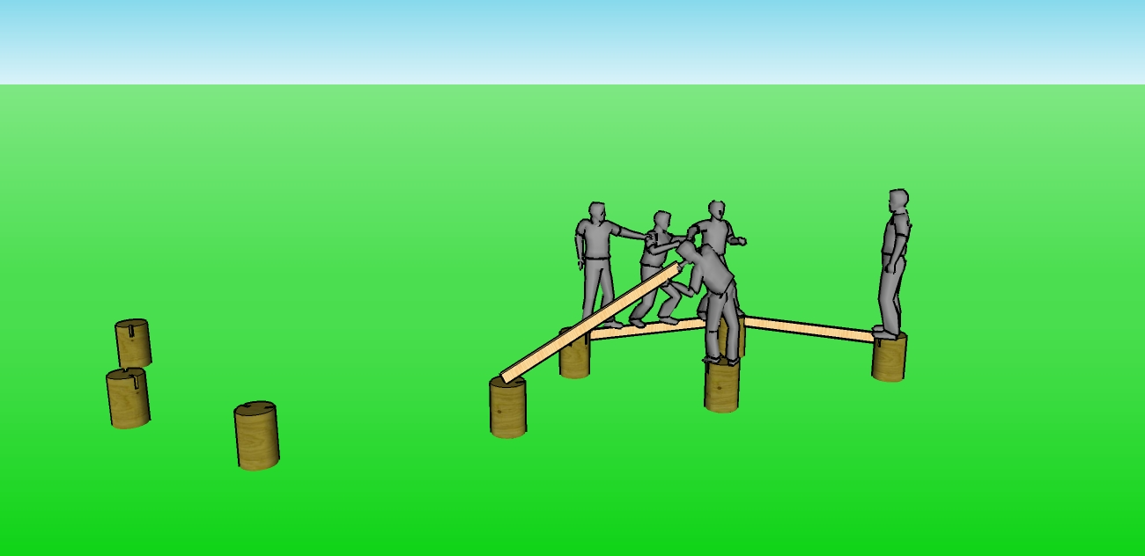
Low Ropes Elements
Artesian Beams
The Artesian Beams is a series of stumps in the ground. The group must work together using the stumps a few provided boards to get from one side to the other. This activities can be used to process a number of issues, such as: communication, problem solving, teamwork, creativity and more.
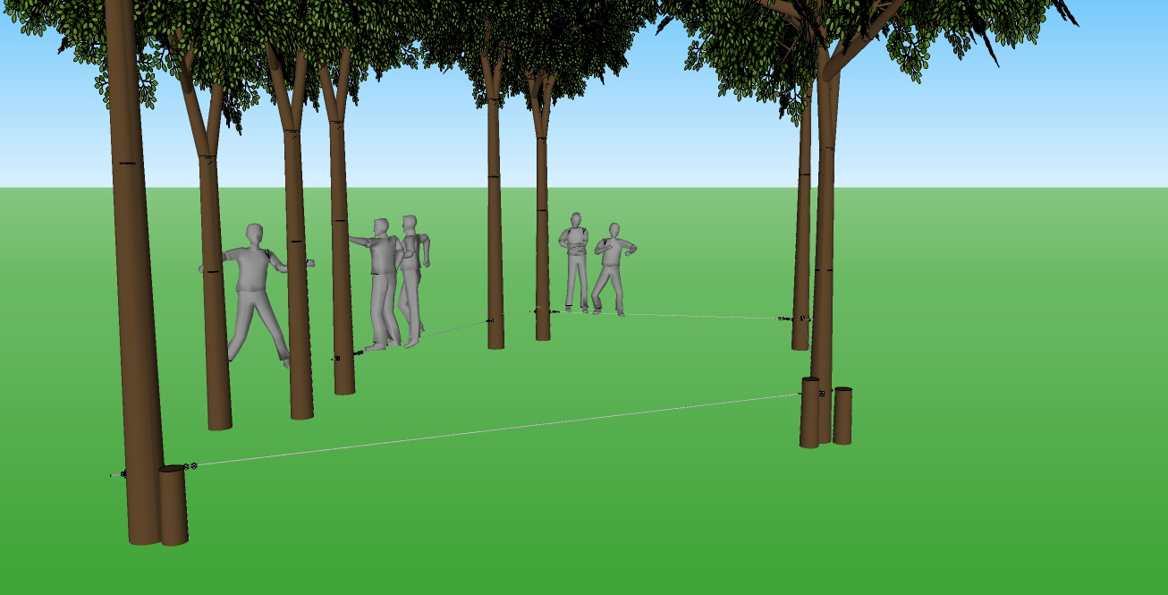
Mohawk Walk
Named after the Mohawk Native Americans that would walk the skyscrapers, team members must traverse a series of small cables without falling off. This activity can be varied in difficulty to challenge even the strongest teams. Problem solving, team work, communication and goal setting are just some of the principles that can be learned with this activity.
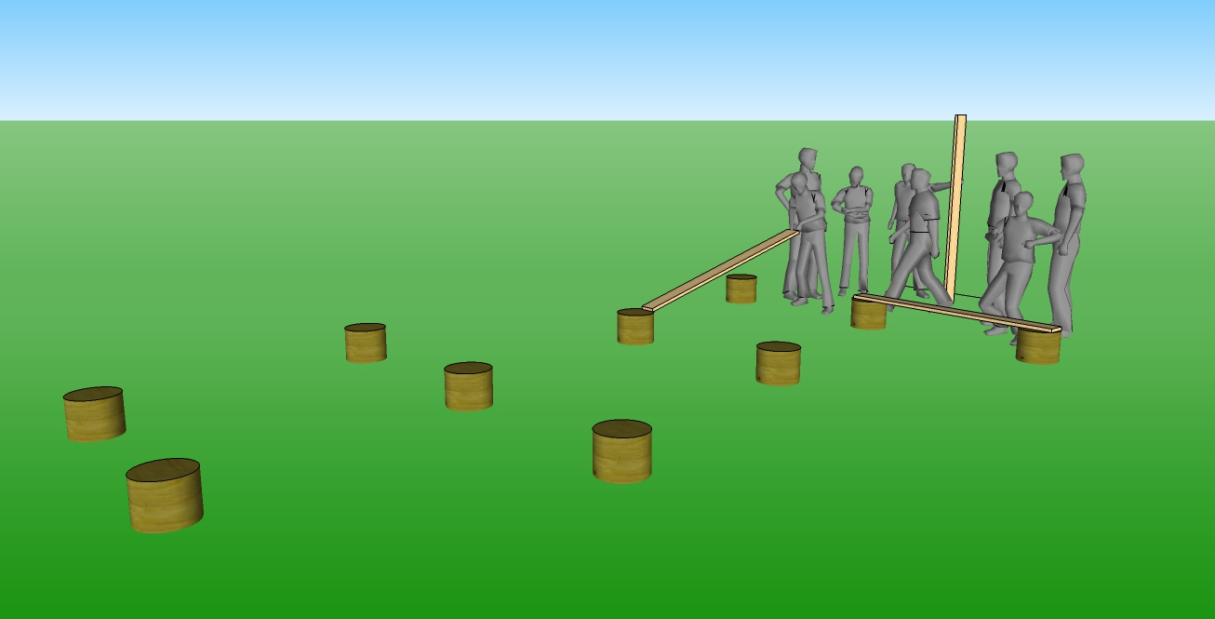
Muse
The Muse is a little bit of a puzzle requiring participants to think about geometry. Participants must cross the area using only the stumps, boards and each other. A great activity for problem solving, team work, goal setting and communication.
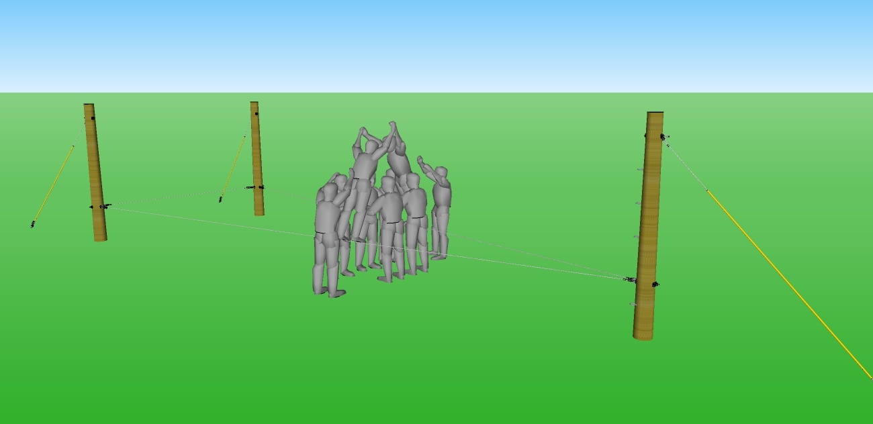
Partner Walk
The Partner Walk is a series of cables run a couple feet off the ground. This element is done in partnerships with the rest of the group acting as spotters. Trust, communication, and cooperation are essential to completing this activity.
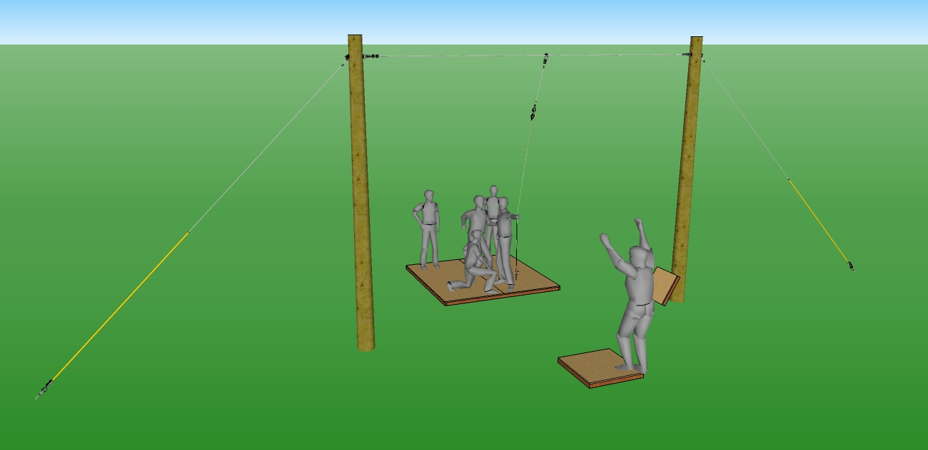
Shark Island
No ropes course is complete without a Shark Island. In this activity, group members must “escape” a sinking ship onto a much smaller lift boat. Teamwork, goal setting, priorities, and problem solving are just some of the principles that can be learned from this element.
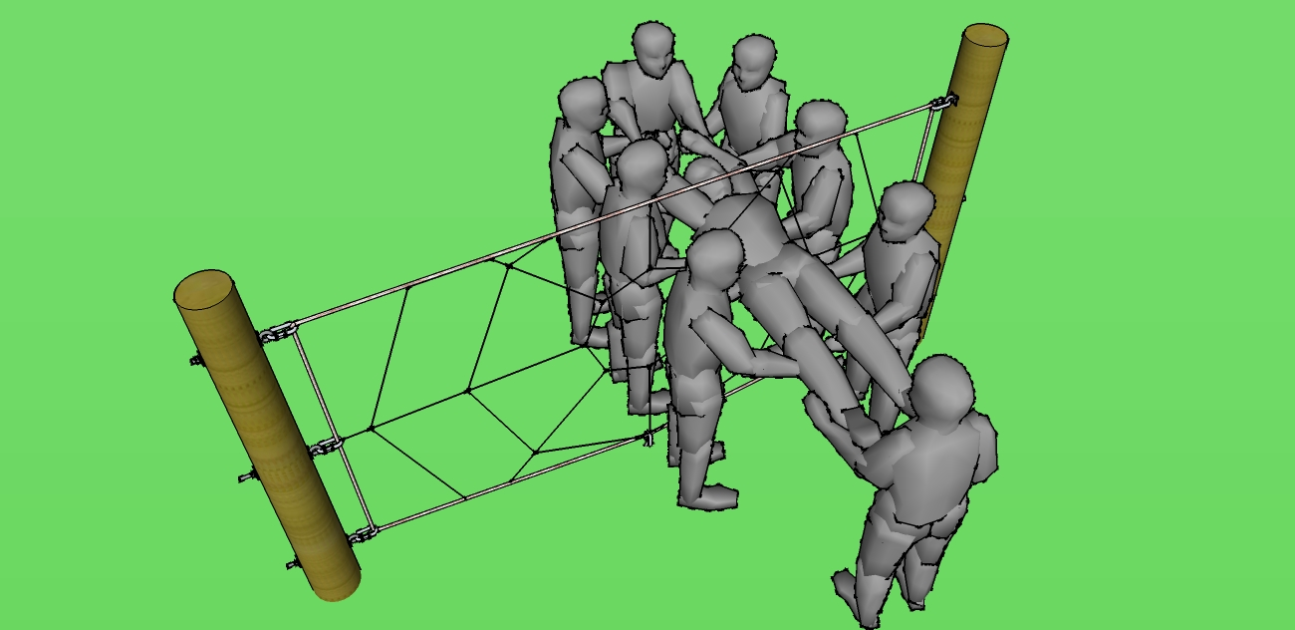
Spider Web
The webs of addiction can be difficult to overcome. This activity helps individuals learn that they can’t do it alone, they must trust and rely on those around them. A great activity for any group.
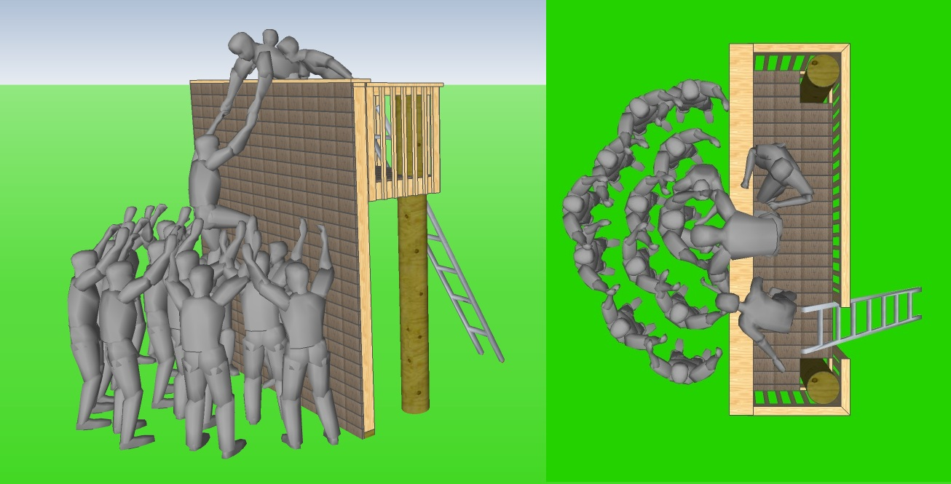
Team Wall
The Team Wall is one of the greatest team building elements available. The entire team must work together to climb up and over the wall. This element is great for individuals to identify the walls in their lives and what it takes to overcome them.
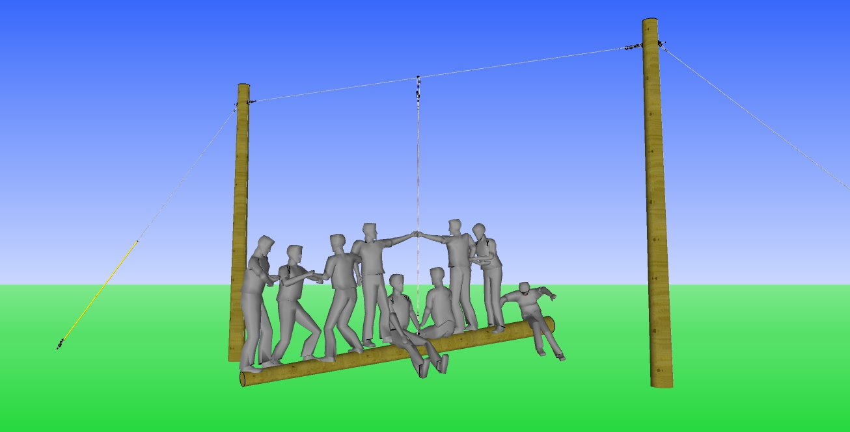
Teeter-Totter
The entire group must balance this teeter-totter. It can be a wild ride as participant learn that it is not just about weight but about finding balance and a solid anchor point in their lives.
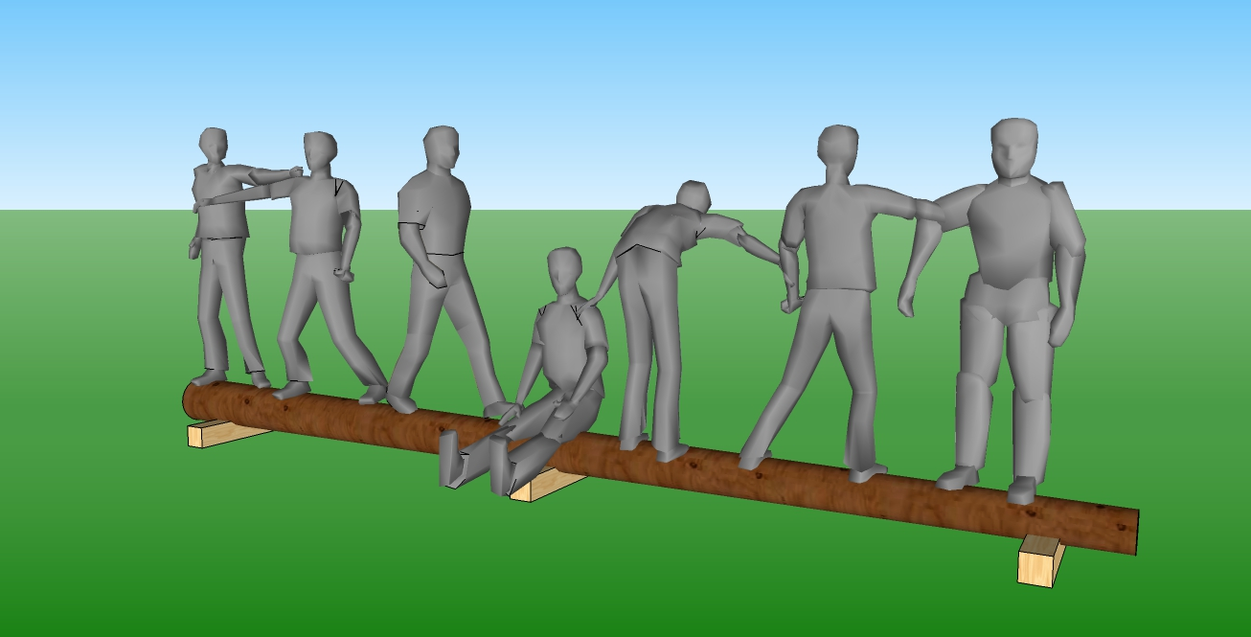
TP Shuffle
In the TP Shuffle groups must figure out a way to rearrange themselves without falling off the telephone pole. Cooperation and patience along with giving support are necessary for this activity.
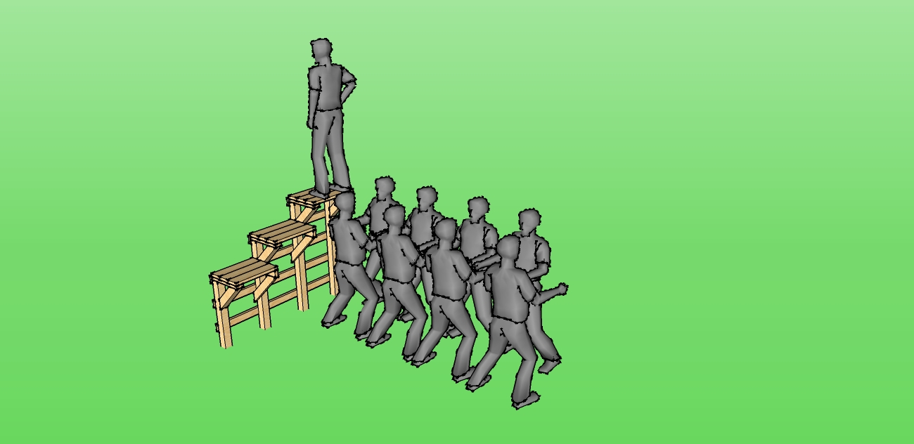
Trust Fall
Possibly the most challenging mental activity on the ropes course, individuals fall from three feet, four feet, or five feet off the ground into their team’s arms. This activity can be a positive means to developing trust in others.

